Steps of Simulation:

1- Creating the urdf and xacro files of the robot. (XML description files)
2- Create a launch file (python file) that starts the
a- robot_state_publisher that publishes the urdf file contents into the robot_description.
b- RVIZ reads the robot_description.
c- Launch the Gazebo program using: gazebo.launch.py
d- Launch the spawn_entity to spawn the robot description files into Gazebo.

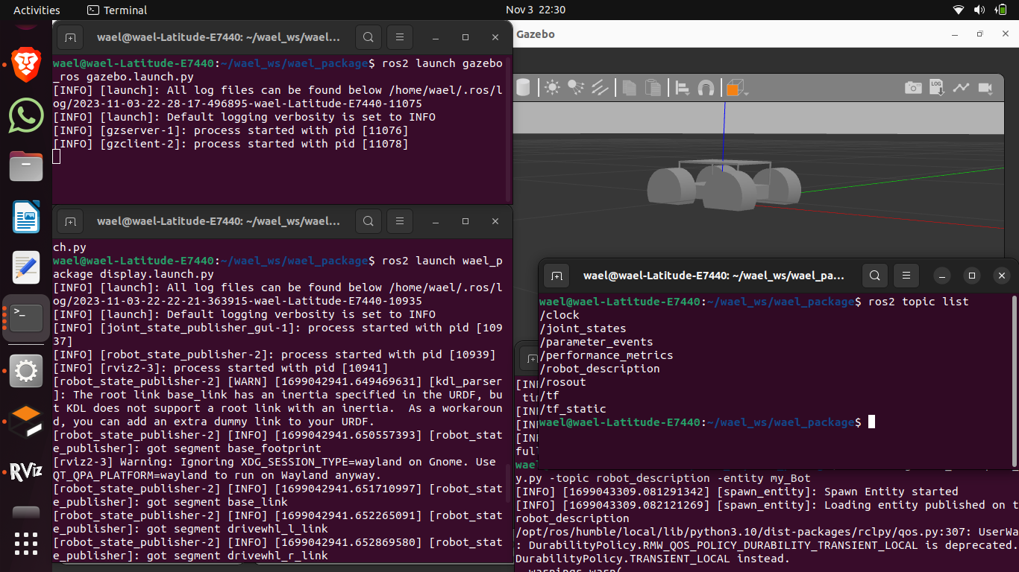
3- We WILL Use the ros2_control library: Same code for the simulated robot will go for the real robot minimizing the difference between the two.
(BUT Now we are replacing the ros2_control library with simple differential drive control system supported by gazebo…)

4- The control system will look like that:
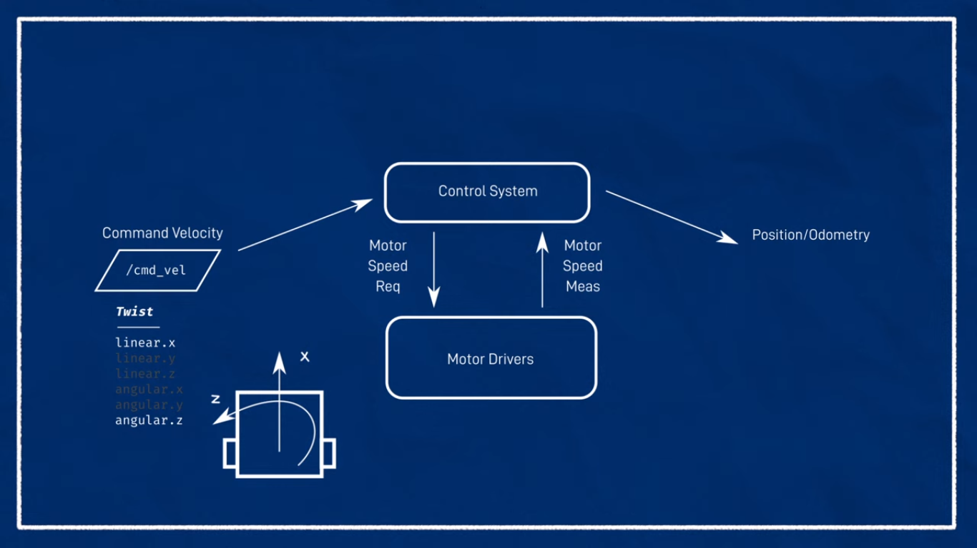
1- Ros2_control library like a control system that will take command velocities from topic /cmd_vel. We have 6 parameters to change, but in differential robot we will manipulate only 2: linear x and angular z.
2- The control system will send motor requests to the motors
3- Motors will give their speed as a feedback (from the arduino encoders).

4- ros2_control will calculate the actual speed to estimate the Position as an ODOMETRY Data (by Dead Reckoning: The basic idea is to integrate the incremental changes in position and orientation over time : IMU AND ENCODERS).
Gazebo Simulation:
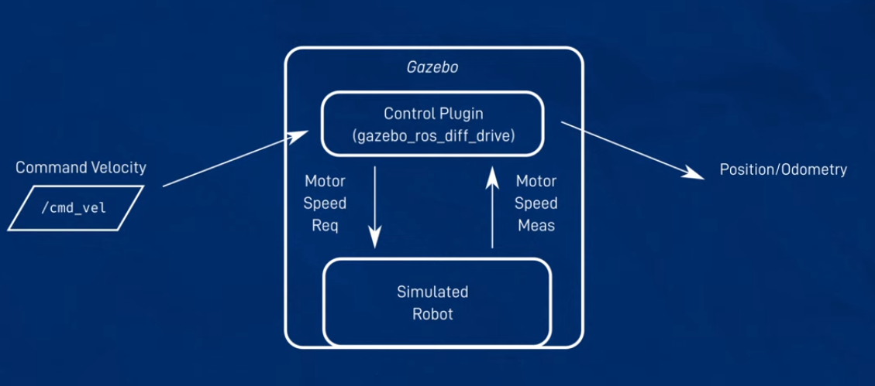
Gazebo Publishes information into the /joint_states and publishes the robot current position into the transform topic. ODOM → Baselink is the estimated current position of the robot from a reference (ODOM) link.
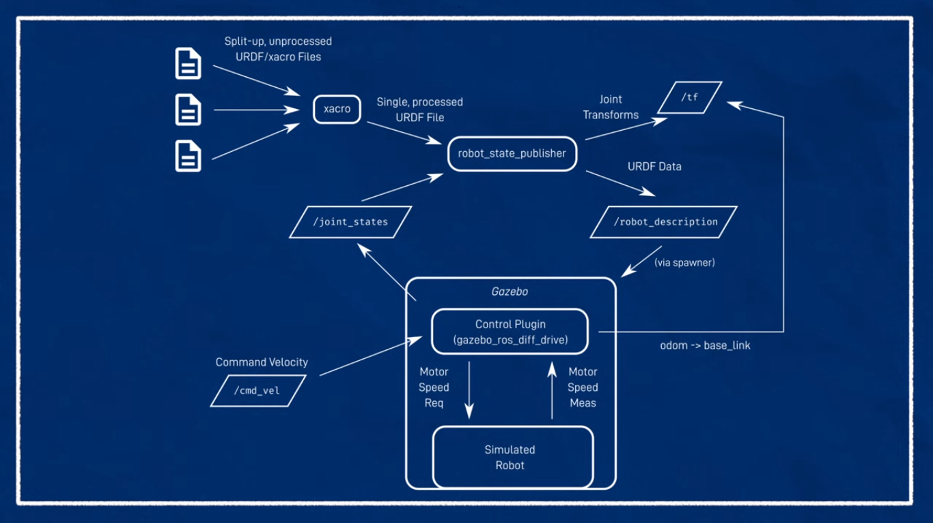
Conceptual design: https://youtu.be/-PCuDnpgiew?feature=shared
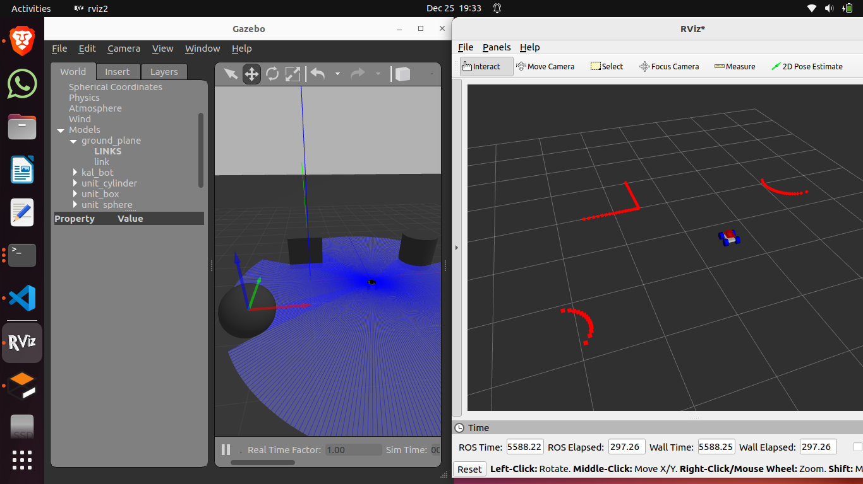
ROS2_CONTROL Library concepts:

Closed loop control should be done by a controller like ROS2_CONTROL library.
Main concept is to bunch the hardware and their drivers with the software algorithms used to navigate the robot around.
It is needed to be at runtime because the real time is crucial factor for the robot navigation. Also, it manages the ros2 topics and services and their rates.
Note: ros2_control doesn’t care about the robot as a whole entity.
It only cares about the specific interfaces setup for that robot.
The resource manager takes care of assembling the commands and readings from all the interfaces at once.
The resource manager is sticked with the robot’s hardware because it is setup as a ros2_control tag in the urdf file.

Code wise:
- Hardware interface: Code needs to talk directly to hardware and be suitable for the standards for ROS2_control
Hardware Interface has 2 main interfaces:
  - Command interface: Contol (Read/Write) on the robot. (Velocity of motor command to motor driver).
  - State interf aces: Read only. (ex: Encoders speed and motor position)

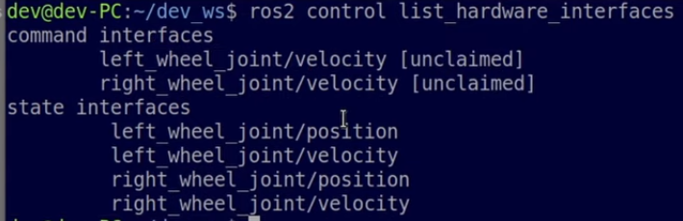

- Controller Interface: Code given as commands or requests from the application interface.
Controller manager is setup by YAML file containing the parameters needed.
Parts:
  - Application Commands Subscriptions (Ros topics).
  - Calculations backend to integrate with the resource manager which controls the hardware.
NOTE: A- Command Interfaces can share the same the State Interfaces in the hardware (to read from) BUT CANNOT share same command interfaces in the hardware.
B- Command Interfaces don’t control anything: They are just an interface between ROS2 topics and the respective interfaces in the hardware.

We should use a node provided by the ros2_control to act as the CONTROL MANAGER of the robot.
1- Provide information about the hardware using the urdf.
2- Provide information about the controller using YAML File.
3- Interact with the control manager using Services or ROS2 command line tool: “ros2 control CLI” or by running seperate nodes.

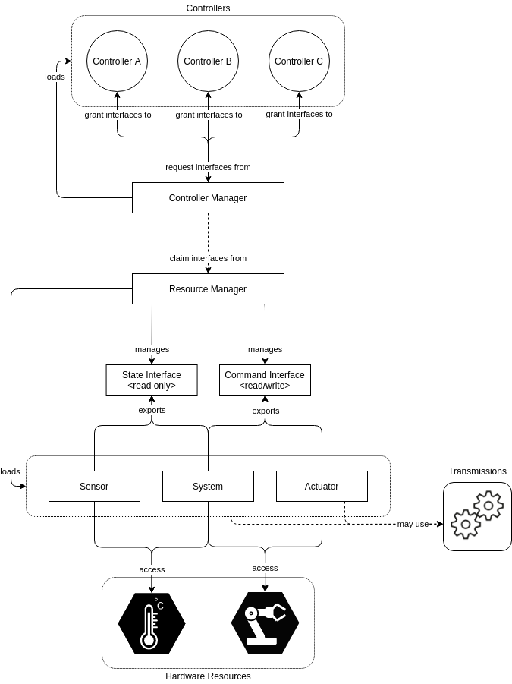
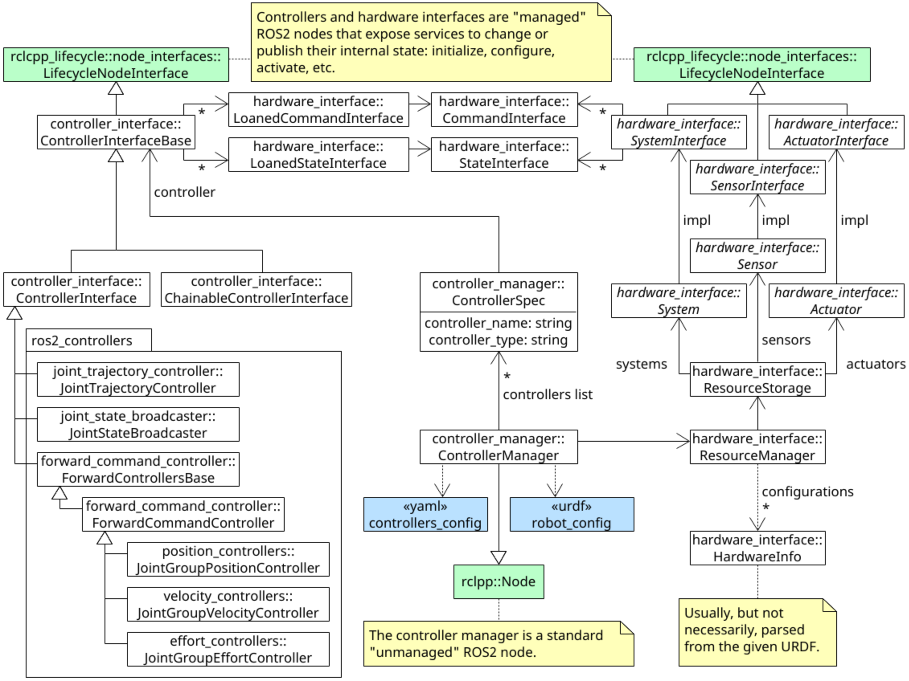

To implement the ros2_control in simulation:
We replace the gazebo file with gazebo tags by ros2_control with its tags.
We check the interfaces by their specific command terminalss.
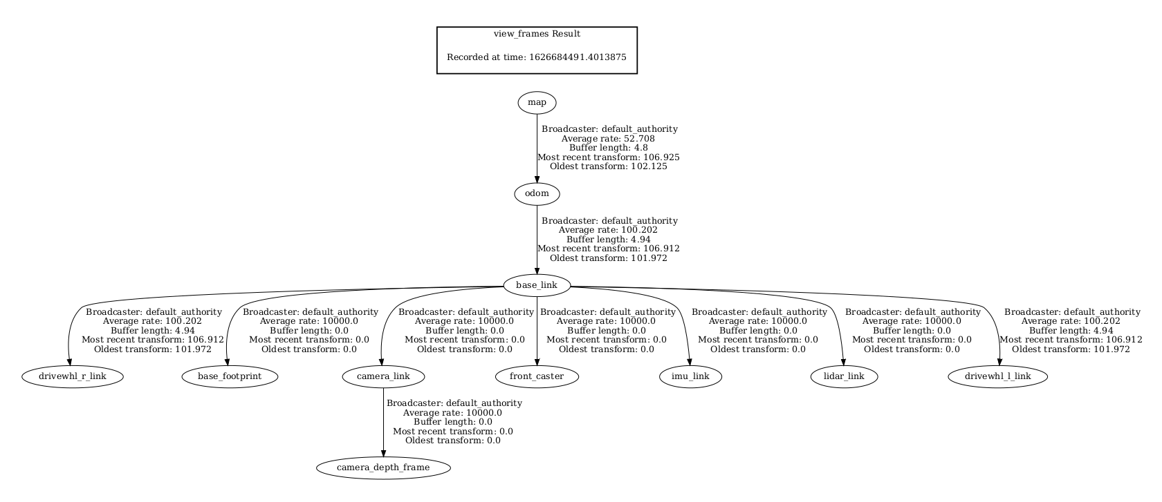
SLAM:
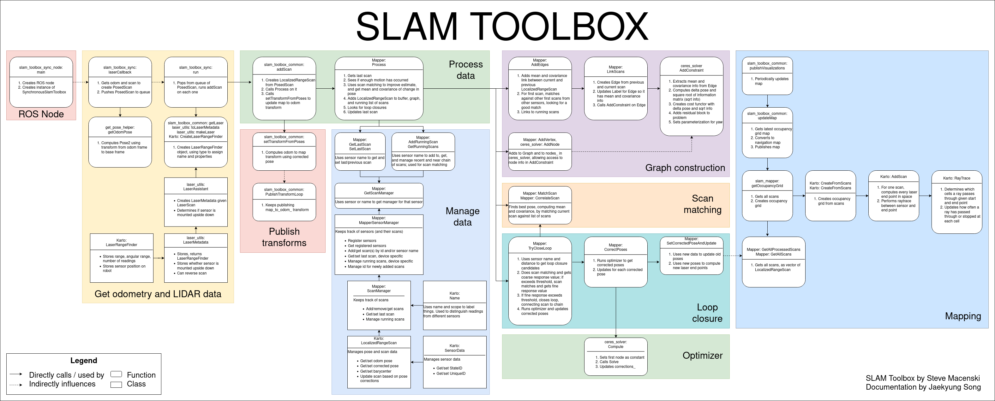
Now we want to simulate the Mapping by creating a Costmap2D with nav2_costmap_2d package provided by NAV2 stack.
The costmap 2D package makes use of the sensor information to provide a representation of the robot’s environment in the form of an occupancy grid. The cells in the occupancy grid store cost values between 0-254 which denote a cost to travel through these zones. A cost of 0 means the cell is free while a cost of 254 means that the cell is lethally occupied. Values in between these extremes are used by navigation algorithms to steer the robot away from obstacles as a potential field.
Main layers that calculates the cost: static layer, inflation layer, range layer, obstacle layer, and voxel layer. The static layer represents the map section of the costmap, obtained from the messages published to the /map topic like those produced by SLAM. The obstacle layer includes the objects detected by sensors that publish either or both the LaserScan and PointCloud2 messages. The voxel layer is similar to the obstacle layer such that it can use either or both the LaserScan and PointCloud2 sensor information but handles 3D data instead. (If depth camera is used).

Note that the camera pi cam publishes its data into the PointCloud2…

Lastly, the inflation layer represents the added cost values around lethal obstacles such that our robot avoids navigating into obstacles due to the robot’s geometry.

AT the level of mapping a new reference in RVIZ should be used which is the map reference link to minimize the error. It will help in the estimation of the robot’s location joining the odom reference we used previously.
So transform from map to base_link is done by the SLAM algorithm while the tf from odom to base_link is the default RVIZ localization technique.
By this way we can calculate the map to odom tf.

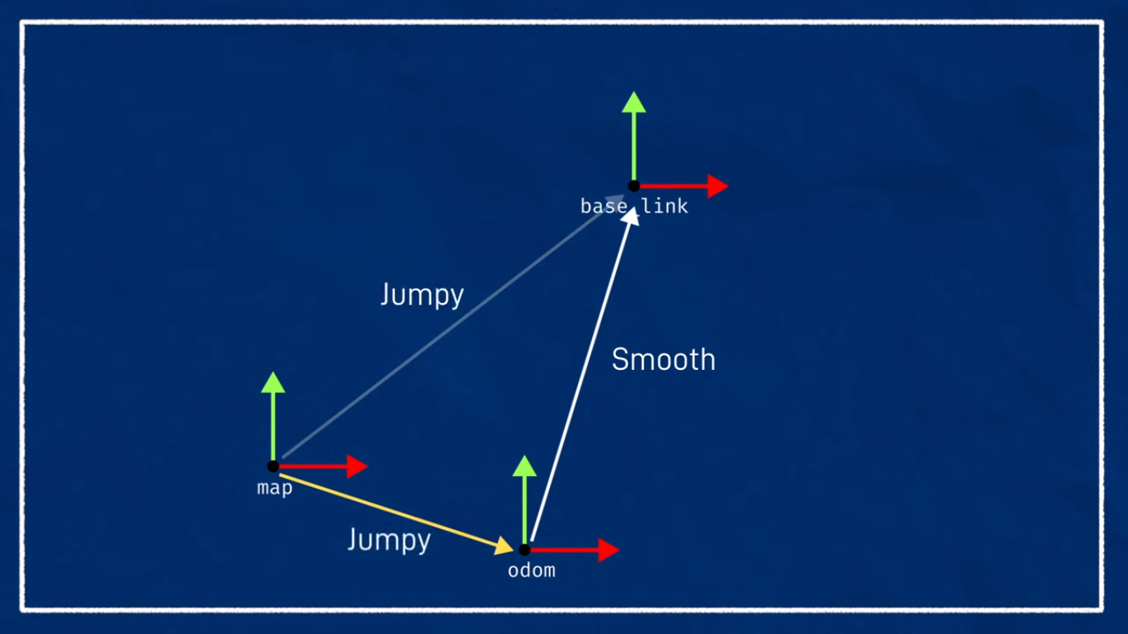
Also this will introduce a new topic related to the occupancy grid:
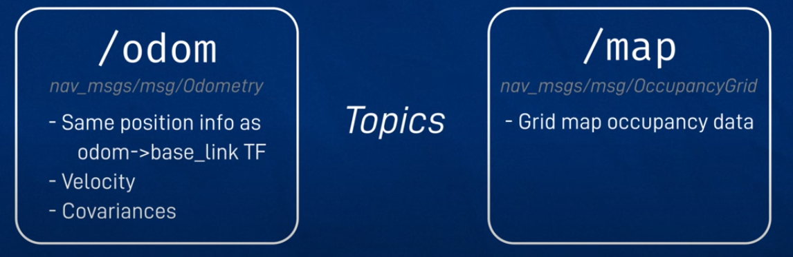

Simulations Map Output
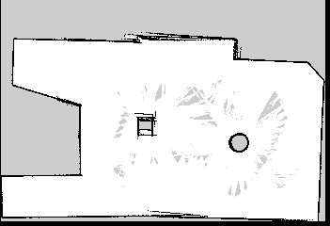

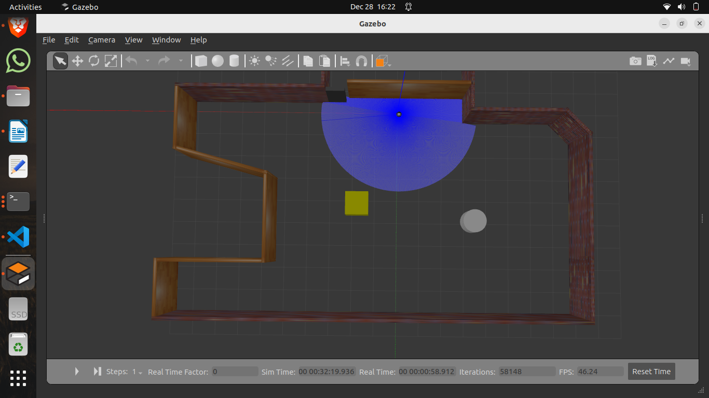
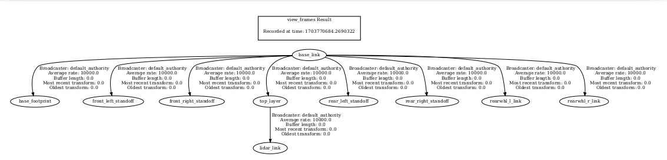
a

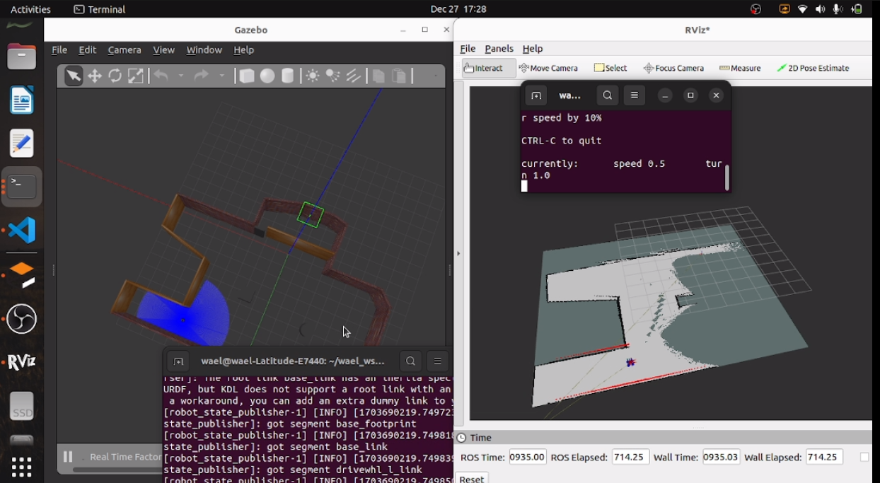
as

NAV2 Stack:

NAV2 is navigation algorithm that allows the robot to autonomosuly navigate from point a to point b in a predefined map.
Navigation is Planning and Execution of a safe trajectory from an initial position to target one. SLAM supports NAV2 by defining the specific position estimate of the robot in the map.

SUMMARY FOR WAEL:
IN SIMULATION:
1- MAPPING: SLAM_TOOLBOX + GAZEBO PLUGIN (TRIED VERY GOOD)
SLAM_TOOLBOX + ROS2_CONTROL PLUGIN ()
2- LOCALIZATION: SLAM_TOOLBOX + GAZEBO (TRIED VERY GOOD)
ROS2_CONTROL WITH

MAPPING | 1- SLAM+GAZEBO | TRIED: VERY GOOD
 | 2- SLAM+ROS2_CONTROL | TRIED: VERY GOOD
LOCALIZATION | 1- ANY MAP+SLAM | TRIED: VERY GOOD
 | 2- ANY MAP+AMCL | TRIED: GOOD
NAVIGATION | 1- ANY MAP+SLAM+NAV2 | TRIED: NEED TUNING
 | 2- ANY MAP+AMCL+NAV2 | TRIED: VERY NOISY

